TIPS for Purchase Request in SpearMart

- Check the catalogs to make sure what you want to purchase is not in one of our catalog suppliers. If it is, order from one of them, or if your quote is cheaper put in a non-catalog order with your quote attached and put in the comments that this quote was cheaper than the catalog supplier. If you need help to show you how to shop from a punch-out or hosted catalog click here for the step by step instructions Microsoft PowerPoint - Shopping from a Punch-Out Catalog 2022 v2 (fsu.edu) or Microsoft PowerPoint - Shopping from a Hosted Catalog 2022 v2 (fsu.edu)

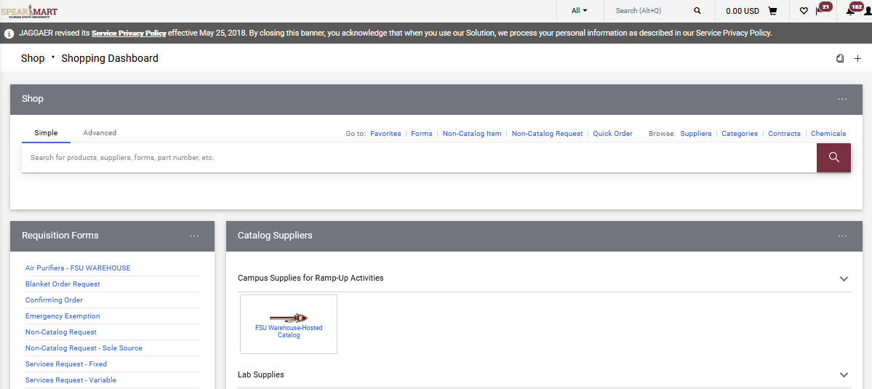

- Amazon is listed in the catalogs, but it is not a contract supplier and should only be used if our contract suppliers do not sell the item you are purchasing. Check the other catalogs first, and if they do not have it or are significantly higher than the one you find on Amazon, then use Amazon and put in the comments that you checked the other suppliers if they either did not have it, or it was significantly higher in price than Amazon. It would be helpful to Procurement to include the part number and supplier you checked.

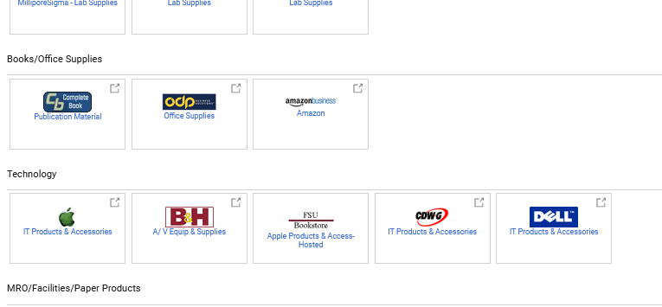
- FORMS: The main ones you will use are Non-Catalog, Services Fixed and Services Variable. You may occasionally use the Software Request, Blanket Order, Change Order, Confirming Order, Non-Catalog, and Sole Source.

  - Non-Catalog: This will be the form you use if what you want to purchase is not a service and is not in our catalog providers. *TIP* Click on the supplier search link FIRST before typing in the box the supplier’s name because typing the name in the box will not give you all the addresses the supplier has. If you click the link first, it’s like an advance search and you can choose from more than just the one address so you can match the address on your quote and order from the correct address for your quote. If you need help to show you how to use the Non-Catalog form, click here for the step by step instructions Microsoft PowerPoint - Shopping using a Non-Catalog Form 2022v2 (fsu.edu)

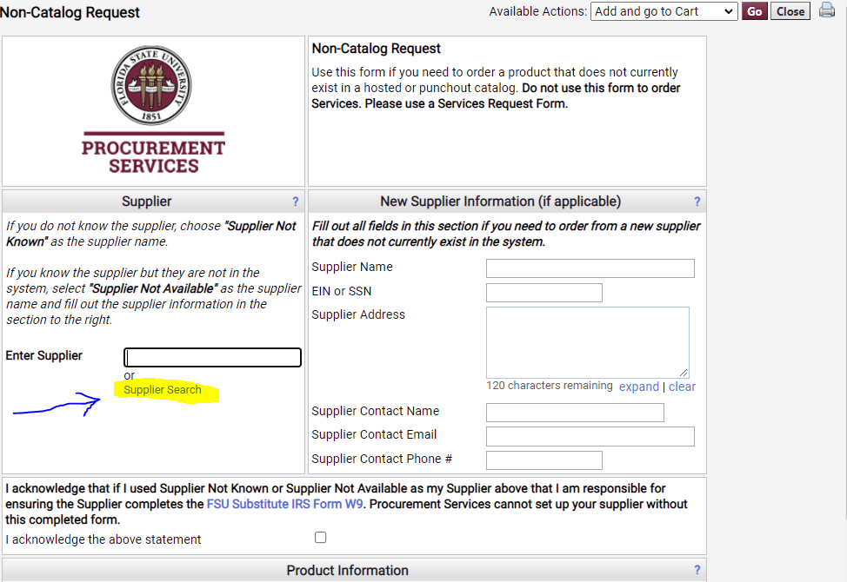

In this example we input Airgas, and you can see we have three addresses for Airgas. If you are putting in a Non-Catalog order or any order that is not a catalog order (service, confirming, etc.) do not use “SpearMart” address. Notice it also has a shopping cart by it, and this address is only for a catalog order. If you use the “SpearMart” address, SpearMart will not know what to do with the order when it’s a Non-Catalog order.
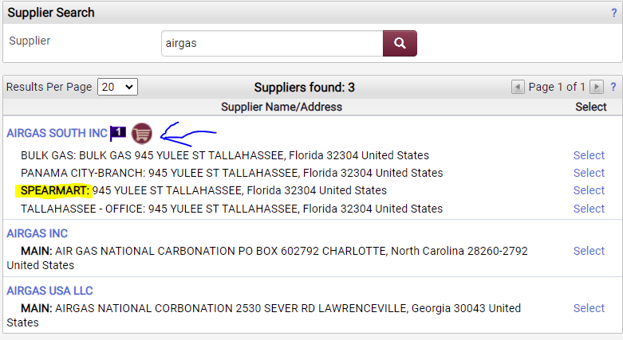
The answer to “was a contract executed in the Contracts module” is no unless there was one executed and then you would include the number of that SpearMart contract. You must have had to work with someone in Procurement Services to get that contract. The fields that are BOLD must have something in them. The others are optional. ITN, ITB and Quote numbers do not go here. 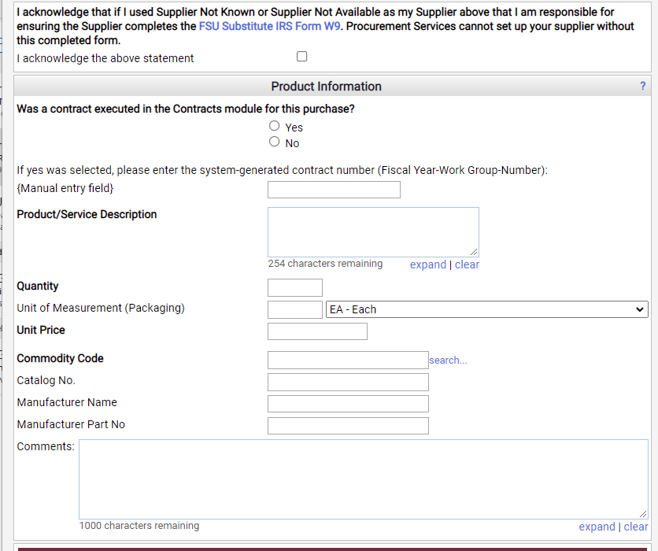
Commodity Code: Click on the search
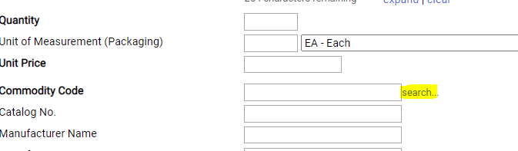

Type in the description what best describes what you are purchasing. Be as specific as possible and you may have to search using different terms until you find one that fits best.
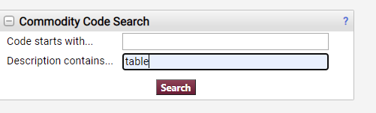
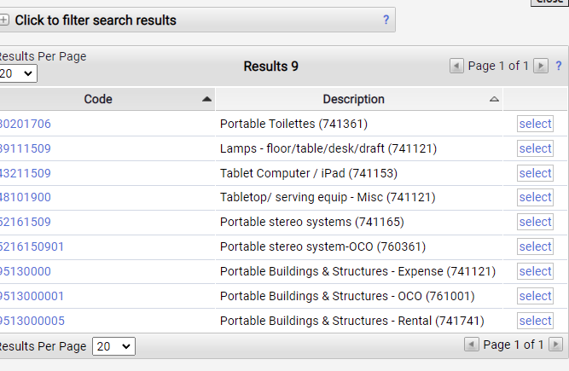

*** Freight (Shipping) has its own commodity code. It is titled “Freight”

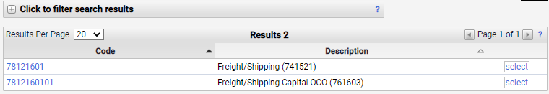

Be specific and if you do not find something then try similar or broader.
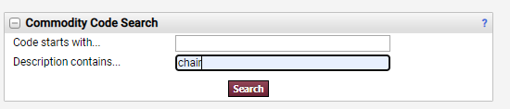
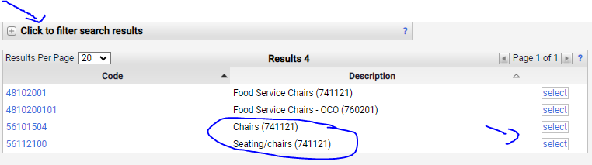

If you need to search more, click on “click to filter search results”
The top two below are for “parts” the underlined one are for service, installation, or repair. Please choose the code that matches best what your commodity is, service or parts.
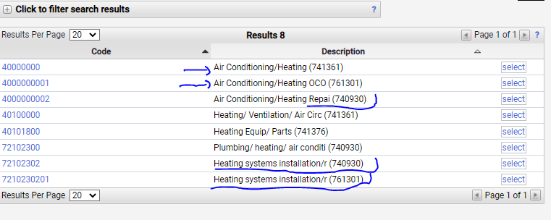
One below is equipment (expense purchase) the other is repair (service)
A lot of times the commodity code for service will end in 02 but not always.
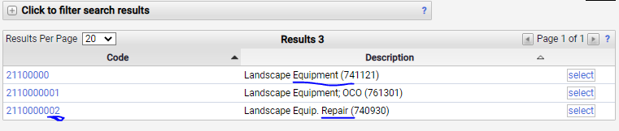

This one does not end in 02 but it is a service. If you were just purchasing plants, you would not use this code.
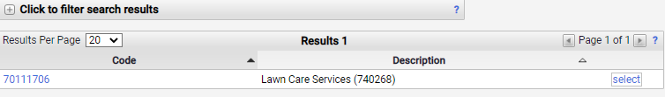

For live plants (trees, etc.) use the first one (see below). The underlined ones are services and should not be used unless you are using a Service form.
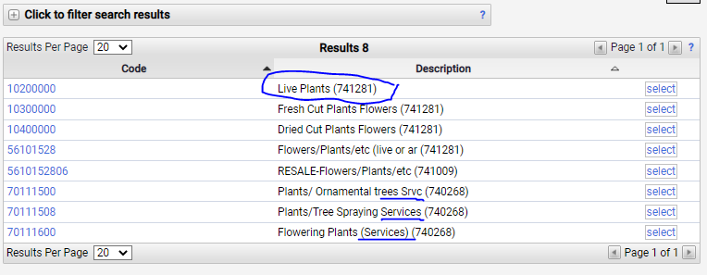

Let say you are looking for a commodity code for pine straw. Just buying pine straw is not a service and FSU will put it where they want it. Looking at the below list you may choose the first one or even 5 down, which makes sense just looking at what is there, but once you select it you can see what category it’s in and that is a big clue that it’s not the right one for pine straw going in a flower bed. The one that works is the “fertilizers/plant nutrients’ for the way you are using the pine straw.
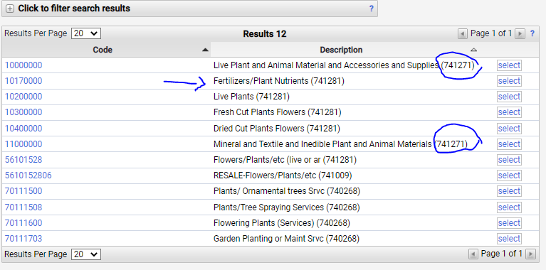

You cannot see the Account Code until you are in your cart. The Account Code is tied to the Commodity Code selected.
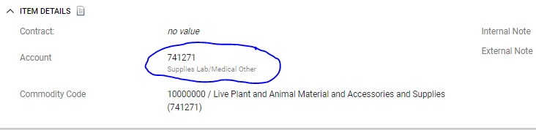

ITN #, ITB #, QUOTE # - Where to put them on the requisition:
You need these numbers to be printed on the Purchase order. Note, that not all fields on the requisition print to the PO. However, you can put the ITN, ITB or Quote number in the description line and/or in the external notes section, which is under the budget info.
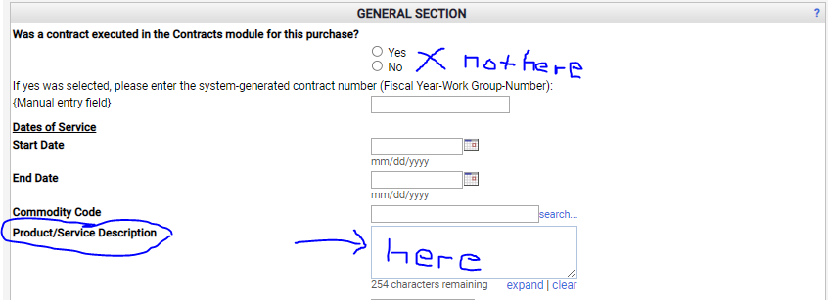

And or

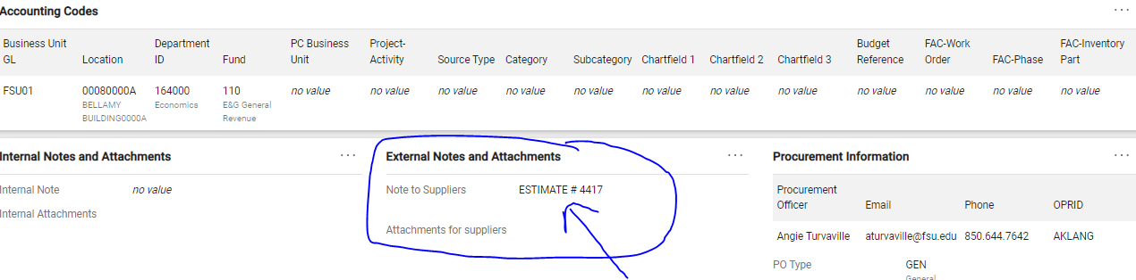
OR
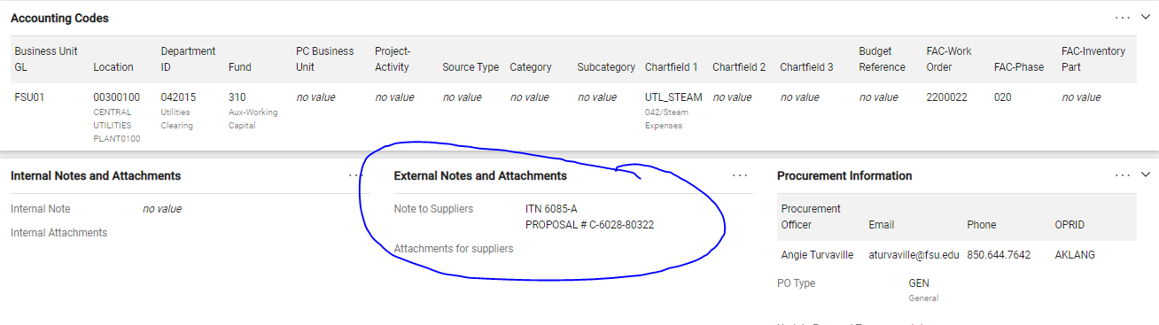
In external notes section I used this verbiage if per a quote, ITN, ITB, etc.
“****************NOTE****************** “Due Date” Listed above is the PO EXPIRATION DATE. Invoice and payment should be completed by that date. If there is a problem, please let us know. Ship date should be upon receipt of this PO or as soon as possible. ****************************************** Please confirm that this Purchase order has Been received by e-mailing acknowledgement To (your email here). ATTENTION: Upon Shipment Please email your invoice to Invoices@admin.fsu.edu
Where to find quote number on supplier’s quote/estimate/proposal:
Usually, the number is at the top and sometimes it is embedded someplace else on the supplier document.
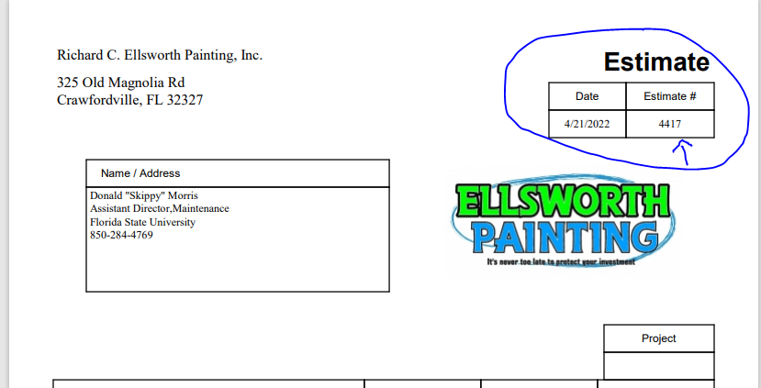
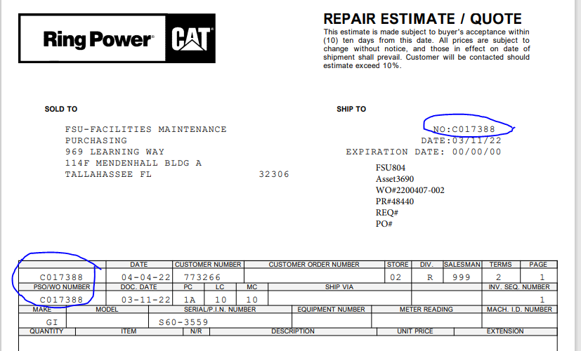
Sometimes the quote does not have a number. Use the date of the quote and the person whose name is on the quote. If no name, use the date (QUOTE 4-15-2022)
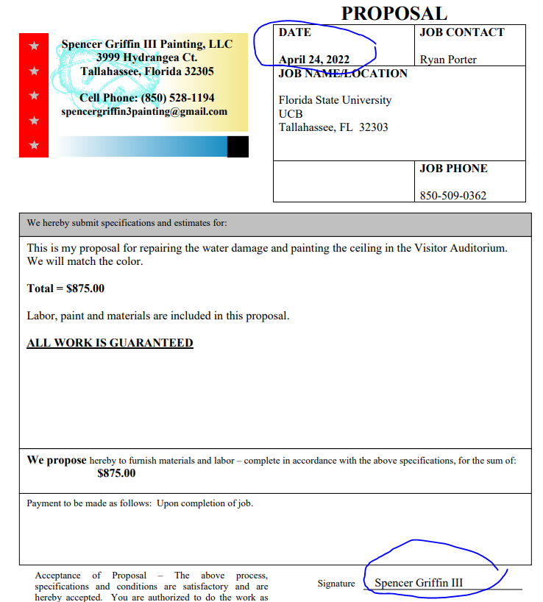

Each item on your quote that has a cost must have its own line on the Requisition/PO (this is true for every form except the confirming order). Once you have completed the first line, go to the top of the form and click on the drop-down box at the top beside “Available Actions” and choose “Add to Cart”
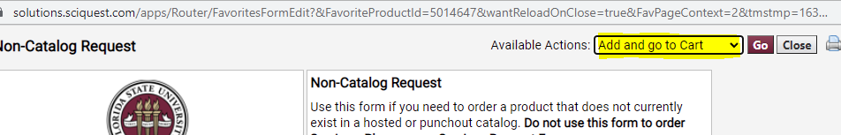

And then click Go.
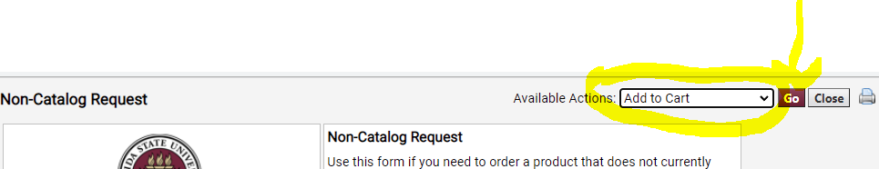

You will have a form that is already filled out with what you put on the previous line, but you can make changes and then click add to cart again and keep doing that until you get to your last line. On your last line change the drop down to “Add and go to Cart”
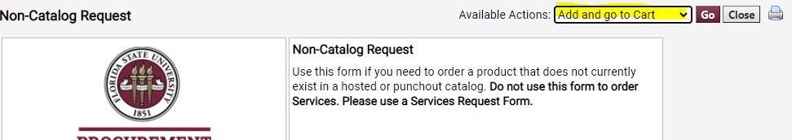

Or, if you do not want your lines to have the previous line info in it and have to change it you can choose “Add to Cart and Return” and keep doing that until you reach your last line and then when you go to submit your last line change to “Add and go to Cart”
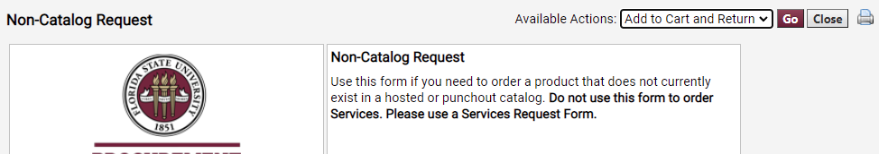

  - Fixed Service Form: Fixed service is when you have a service that has one cost. Not a list of costs that have a total cost but just a flat cost. The supplier gives you a quote for the service you have requested and there is only one cost line with only one quantity, or no quantity listed. You can have more than one line on a fixed service, but not more than one quantity per line. Each line on the quote that has a cost must be a separate line. If you are putting in a request for service on a piece of equipment please include the make, model, and serial number of the equipment and if it has a property tag include the number off the tag. If it is a service contract and is priced/billed according to which services were performed and they are unknown at time of requisition, attach a fee schedule/pricelist of all that could be performed/provided for this contract period.
For step-by-step instruction on completing the Fixed Services Form click here: Microsoft PowerPoint - Shopping using a Services Request - Fixed Form 2022v2 (fsu.edu)
FINDING THE DESCRIPTION:
The description for a service is what the supplier is going to do or provide. For example, on the below quote, the description that would go on the requisition is highlighted:
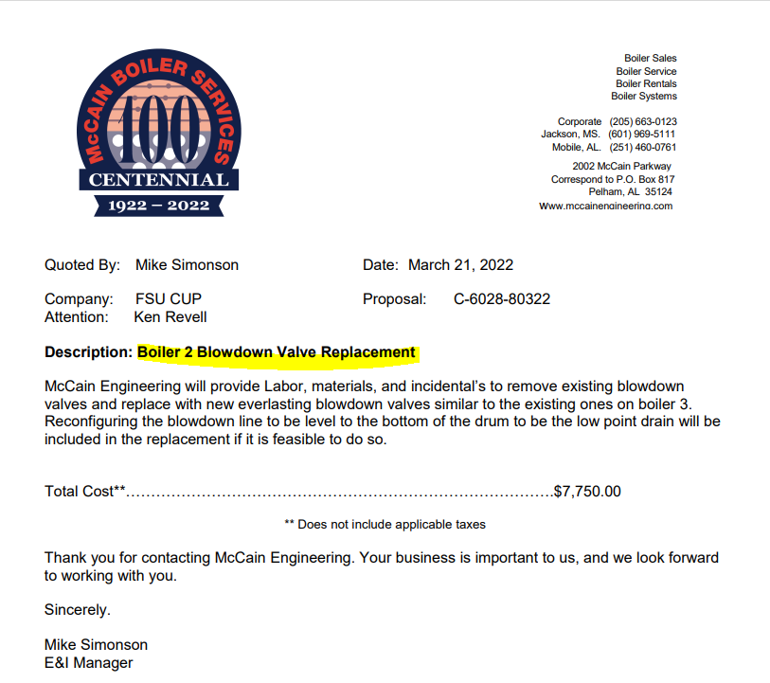
This would go on a fixed service form because it is one flat cost, not broken down into hours, etc.

The SCOPE on the fixed service form for this order would be the whole paragraph: 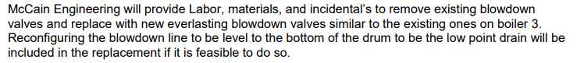

The PURPOSE is why you need it. This is something the end user will need to tell you. Boiler needs a valve replaced, but why? These questions are not to make life more difficult for you, but, they are to help when we are audited. It’s a lot easier on everyone if the answers to the auditors’ questions are with the order instead of having to go back later and try and figure it out.

  - Variable Service Form: If you have more than one quantity per line you will need this form. This can be one line or multi lines, and it’s the quantity per line that is important. Quantity of more than 1 requires the variable service form. If you have a service quote that has 10 lines on it and 9 of them are a quantity of 1 but one line has a quantity of 5 you would do a variable service form for the whole order (you cannot use multiple forms on one order) and put quantity as 1 for all lines except the one that has 5 you would put 5. If you are putting in a request for service on a piece of equipment please include the make, model, and serial number of the equipment and if it has a property tag include the number off the tag. For step by step instructions on completing the variable service form click here Microsoft PowerPoint - Shopping using a Services Request - Variable Form 2022v2 (fsu.edu)

Example of a variable service is below. Since the oil is priced out 5 per each that makes it a variable service. Just one line with a quantity more than 1 on a quote will make it a variable service. Since this example is service on a vehicle, the Make, Model, and VIN # are required in the description or scope of this order. The estimate # is also good to reference for the supplier.
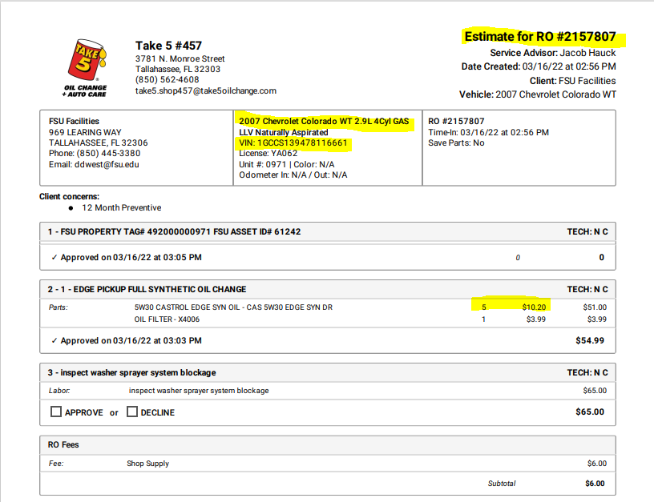

  - Software Request: All software or web services type purchases need to go on this form. This form has specific questions that IT needs to know to approve the purchase (it routes to them for review). You complete the top of the form “general section” just like the non-catalog form. The software checklist part needs to be completed but the sole source section does not need to be completed unless it is a sole source, meaning there is no other supplier in the world you can purchase this from and if they go out of business you would not be able to get it. For step by step instructions on completing the software form click here Microsoft PowerPoint - Shopping using a Software Request Form 2022 (fsu.edu)
  - Blanket: Blankets cannot be used for services. They also must have a fee schedule/price list attached and be very detailed about what is to be purchased. For step by step instructions on completing the blanket form click here Microsoft PowerPoint - Shopping using a Blanket Form 2022 v2 (fsu.edu)
  - Change Order:
1. Prices and quantities cannot be changed on any “catalog” order.
2. Supplier names and supplier addresses cannot be changed on any orders. Requester must cancel the original PO and submit a new requisition.
3. Blanket request forms and Services fixed forms come across to OMNI as “Amount Only” which means they can receive the amount/price of an invoice and not the quantity.
4. If a Non-Catalog requisition is received and you see that the price and quantity are switched, please change it to a quantity of “1” and put the “amount of money” in the “price. Now, you will have to wait for the PO to be dispatched, so email Ruth the PO number and tell her to make it an “amount only, PO in OMNI. Or, you have the option to send it back and ask them to put the requisition on a Services Fixed PO.
5. Regarding #3, the reason for this is that it will make Commitment Control error if we keep it where the amount of money is in the quantity and the actual quantity (1) is under the price.
6. If a change order is submitted to make a PO a blanket when in fact it is a Non-catalog, you can approve it and Ruth will go into OMNI and make it an “Amount Only” PO.
7. Do not approve any change order in which they are requesting to add a line to a PO where the quantity and price are switched as all this will do is add to year-end errors and issues. Please advise the requester to do a new PO and reference the original PO.
8. Changes to budget and/or distributions cannot be made once the PO is received and/or vouchered. If PO is receipted only, have the requester delete the receipt(s) involved and then approve the change order. If PO is vouchered, return the requisition, and tell them to do a budget transfer.
9. Ship to addresses cannot be changed.

This link will take you to step by step how to complete a change order. Microsoft PowerPoint - Submitting a Change Request Form 2022v2 (fsu.edu)
  - PO Due Date Extension/Roll Request: To extend the due date choose this form. All you need is the supplier number, PO number, commodity code used on original PO, the current due date and what you want to change the due date to. There are limitations to this, as a due date cannot be extended if it has already past and/or if it has already rolled once it cannot roll a second time (into another fiscal year).
  - Non-Catalog Sole source: Is only for orders that are over $75,000 and there is no other supplier that can provide that item. You would complete this form just like the Non-Catalog form, but you would also complete the Sole Source section at the bottom of the form. For step by step instructions on completing the sole source click here Microsoft PowerPoint - Submitting a Sole Source Request 2022v2 (fsu.edu)
  - Confirming Order (After-the-fact orders): Is not guaranteed payment. Without an approved university payment method (valid University Purchase Order in place before the start of service or prior to ordering goods) to authorize retroactively commitments to suppliers by personnel is a violation of university policy.
It’s purchase, letter of intent to purchase, or request for scheduling, that is made by an individual, without having a valid purchase order number, P-Card at point of sale, or approved payment request form, established to pay for that purchase or service.

Procurement Services will review all confirming requisitions on a case-by-case basis and will have the option to disapprove any request that was not determined to be an emergency, or when a purchase order could have been obtained. Disapproval will result in the cost of the purchase being borne by the individual who contracted with the supplier without a purchase order number. Neither Payables & Disbursements Services nor the University Business Administrators will process direct pay requests for purchases that could have and should have had purchase orders in advance.

If you have a bona-fide emergency and the University is closed or you’re in travel status and do not have a P-Card or supplier doesn’t accept P-Card, document the nature of the emergency, and turn in your paperwork by the next business day to Procurement Services for review. If it is a true emergency, then Procurement Services will approve the request.

For more reference information, go to the Procurement Services website and look up “How to Buy”:
https://procurement.fsu.edu/how/buy
The shopping guide can be helpful for locating contract suppliers:
https://procurement.fsu.edu/how-buy/shopping-guide
Procurement Quick Reference Guide:
https://procurement.fsu.edu/sites/default/files/media/doc/Procurement%20Quick%20Reference%20Guide.pdf
Expenditure Guidelines on the Controller’s website:
https://controller.vpfa.fsu.edu/sites/g/files/upcbnu1236/files/documents/Accounts%20Payable/Expenditure_Guidelines.pdf

***** More Training: This is where you will find the job aids, linked above along with many more. If you have a question on how to do something this is a great resource:
https://procurement.fsu.edu/Training

