**Digital copies of receipts need to be retained for 5 fiscal years minimum, and hard copies of receipts still need to be retained for a minimum of 2 fiscal years, per policy. The attachments are for our monthly Reconciliation purposes**

**Receipt Attachment Instructions**

1. **Search for your transactions in the “Reconcile Statement” screen.**

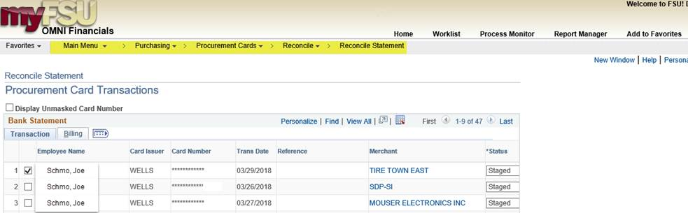

1. **Scroll to the right and click “Attachment” next to the transaction that you want.**

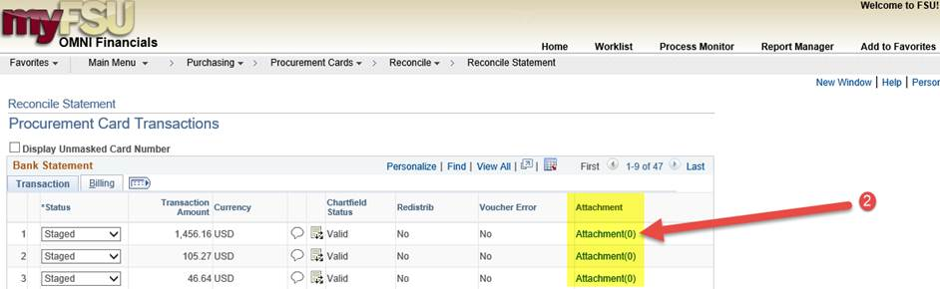

cid:image003.jpg@01D3D6FA.3A1689C0

1. **Click the paperclip icon under “Add”. (If you have more than one attachment, click Add Attachment and another line will appear for it)**

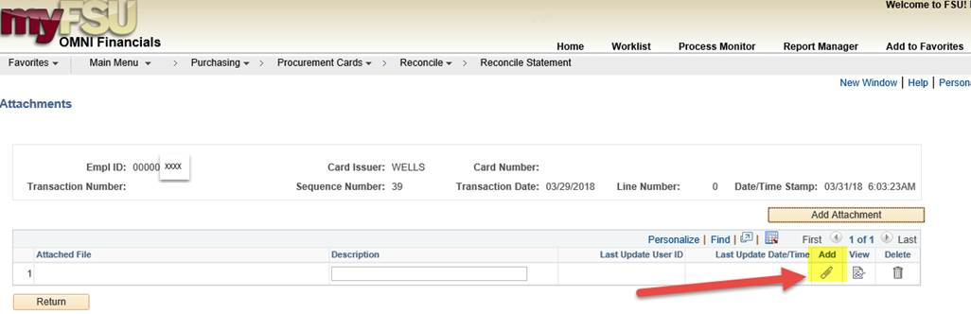

1. **Click “Browse” and select your receipt.  Then click “Upload” to complete the attachment.**

**You can delete the attachment if you need to, by clicking the trash can icon under “Delete”.**

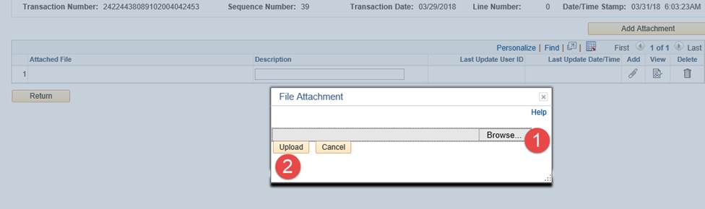

**How to view or Attach Receipts *After* Charges are processed**

This is a good time to re-introduce everyone to our P-Card Reconciliation Query in OMNI Financials:

**FSU_CTRL_AP_PCARD_RECON**

With this you will be able to pull up cardholders’ charges for a given period of time (month-to-month for our Reconciliation purposes). The first column of each charge will have a link to the voucher that the charge pertains to. The receipt attachments are stored in the vouchers.

1. Go to Query Viewer in **OMNI Financials** and search for **FSU_CTRL_AP_PCARD_RECON.** Add to your favorites and run it (Excel is best because you can filter the info).

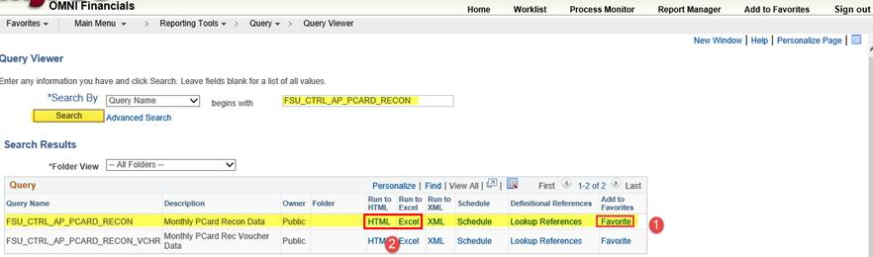

1. Enter the time period you are looking for and the Cardholder’s FSU employee ID# (*To search by name, click the Magnifying Glass Icon*). Then click “**View Results**”. You can also search by dept, but we recommend putting % there.

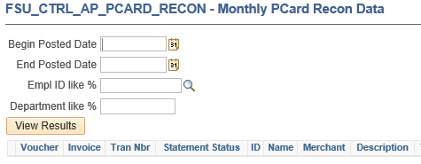

1. The charges will be listed. If a charge has already been processed, it will have a link to its voucher in the 1st column. Click the **voucher number link**.  (The query will soon be able to show whether or not there has been a receipt attached)

cid:image008.png@01D3D6FA.3A1689C0

1. The link will take you to this page (Regular Entry). Click the “**Invoice Information**” tab.

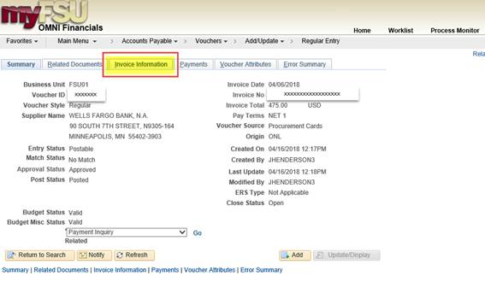

1. Near the bottom-right of the screen, click “**P-Card Attachment**”.

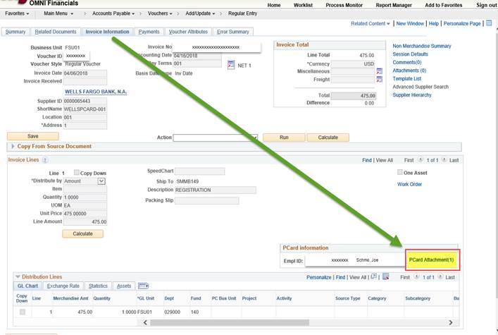

1. Finally, click the **paper clip** icon under “Add”, near the bottom-right. Select your receipt and upload it.

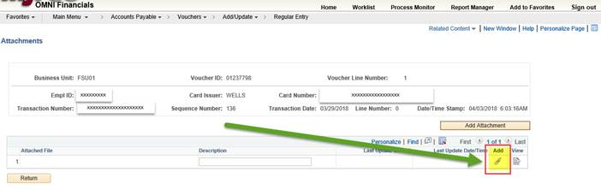

If you have questions on attaching receipts, please direct them to our P-Card Staff:

Derrick Myrick ([dmyrick@fsu.edu](mailto:dmyrick@fsu.edu))

Blaine Fasone ([bsineath@fsu.edu](mailto:bsineath@fsu.edu))

Joy Henderson ([jhenderson3@fsu.edu](mailto:jhenderson3@fsu.edu))